DEPARTMENT OF COMPUTER SCIENCE AND ENGINEERING (CYBERSECURITY)
AMET UNIVERSITY, KANATHUR, CHENNAI

FINAL YEAR PROJECT — PHASE I / FIRST REVIEW
Attack Path Risk Engine
An Extension of Cartography for Automated Multi-Hop Attack Path Discovery and Risk-Based Prioritisation in Cloud Environments

1. Project Title
Attack Path Risk Engine: An Extension of Cartography for Automated Multi-Hop Cloud Attack Path Discovery and Risk-Based Prioritisation.

2. Team Details
S.no | Name | Register No. | Department
1 | Mohamed Abdul Baasid | ACS23004 | CSE (Cybersecurity)
2 | Rahsheetha | ACS23007 | CSE (Cybersecurity)
3 | Kithiyon | ACS23003 | CSE (Cybersecurity)

3. Problem Statement
Given a graph of infrastructure assets, identities, and permissions such as the one Cartography already constructs, there is currently no automated mechanism to (a) discover the set of multi-hop paths connecting publicly exposed or otherwise vulnerable entry points to sensitive targets such as production data stores or administrative roles, (b) quantitatively score each discovered path by its relative risk, and (c) present these findings in a form that is actionable without requiring manual graph-query expertise. Real-world cloud security incidents rarely stem from a single dramatic vulnerability; they arise from a chain of ordinary, individually low-severity misconfigurations that together connect an internet-exposed asset to sensitive data. This project addresses all three sub-problems above.

4. Project Abstract
Cloud security incidents rarely come from a single flaw. They come from a chain of ordinary misconfigurations that together lead from an internet-exposed asset to sensitive data. Cartography, a CNCF sandbox open-source tool, already collects cloud inventory from more than thirty platforms into a Neo4j graph, and its own documentation names attack-path discovery as a goal — but today that discovery is entirely manual, requiring a security engineer to hand-write a Cypher query for every question asked of the graph. This project builds the Attack Path Risk Engine on top of that existing graph: a depth-bounded, multi-hop traversal that automatically enumerates paths from exposed entry points to sensitive targets; a quantitative scoring model that rates each discovered path from 0 to 100 based on target impact, hop count, the type of privilege gained at each transition, and any mitigating controls present; and a web-based dashboard that reports the ranked findings in plain, actionable language rather than raw graph-query output. Validation is carried out using a seeded AWS sandbox environment populated with deliberately constructed, realistic misconfigurations, chosen specifically because no public benchmark dataset of labelled cloud attack paths currently exists. Cartography's own source code remains entirely unmodified throughout; every new capability is implemented as a separate, clearly attributed module, in line with the project's Apache 2.0 licence. The project is planned across the full academic year: Phase I delivers the path-discovery and risk-scoring layers (targeted at roughly 40% overall completion), and Phase II delivers the dashboard, full integration, validation, and final documentation (the remaining 60%). The result is intended to be a genuinely usable, technically substantial extension to a credible, actively maintained open-source security project, addressing a gap its own maintainers explicitly acknowledge but have not yet automated.

5. Objectives
- To study and document Cartography's existing architecture, data schema, and analysis pipeline in sufficient depth to identify precisely where new functionality should be introduced without modifying the base project's own source code.
- To design and implement a path-discovery module that automatically traverses the infrastructure graph from defined entry points to defined sensitive targets, within a bounded search depth.
- To design a quantitative risk-scoring model that ranks discovered paths by severity, based on documented, industry-recognised cloud attack-path concepts.
- To build a web-based dashboard that presents ranked findings in plain, actionable language for a security reviewer.
- To validate the system against a set of deliberately constructed, realistic misconfiguration scenarios in a controlled sandbox cloud environment.

6. Domain Identification
Primary domain: Cybersecurity.
Sub-domains: Cloud Security, Cloud Infrastructure Security, and Attack Path Analysis. The project sits at the intersection of graph-based security analytics and cloud identity and access management (IAM).

7. Literature Survey
Eleven papers were reviewed, spanning IEEE, ACM, USENIX, Springer, Elsevier, Wiley, and arXiv sources, all published within the last five years. The survey deliberately concentrates on cloud IAM privilege escalation, attack-path generation, and attack-graph scalability, since these map most directly onto the project's core contribution.
# | Paper | Venue / Year | Relevance
1 | Multi-target Risk Score Aggregation for Security Evaluation of Network Environments | IEEE CloudCom, 2024 | Pairwise path-based score aggregation across a network — directly informs the project's scoring-formula design.
2 | Fixing Privilege Escalations in Cloud Access Control with MaxSAT and Graph Neural Networks (IAMPERE) | IEEE/ACM ASE, 2023 | Automated detection and remediation of IAM privilege-escalation chains in cloud graphs.
3 | SkyEye: When Your Vision Reaches Beyond IAM Boundary Scope in AWS Cloud | arXiv, 2025 | Cross-principal AWS IAM enumeration — relevant to entry-point and privilege-boundary identification.
4 | CloudLens: Modeling and Detecting Cloud Security Vulnerabilities | arXiv, 2024 | Formal relational model of cloud IAM plus a planner that generates attacks to find vulnerabilities — closely related modelling approach.
5 | BRIDG-ICS: AI-Grounded Knowledge Graphs for Intelligent Threat Analytics in Industry 5.0 Cyber-Physical Systems | Springer (Cybersecurity, open access), 2026 | Neo4j Graph Data Science attack-path analysis using Yen's k-shortest-path and Dijkstra's algorithm — methodologically close to the project's path-discovery layer.
6 | Behind the Scenes of Attack Graphs: Vulnerable Network Generator for In-Depth Experimental Evaluation of Attack Graph Scalability | Computers & Security (Elsevier), 2025 | Addresses attack-graph scalability and synthetic dataset generation — informs the project's sandbox-validation approach.

8. Research Gap / Existing-System Gap
- Cartography and comparable graph-based cloud inventory tools build a complete, queryable graph of infrastructure, identities, and permissions, but none automate the search for multi-hop attack paths within that graph — a security engineer must hand-write a Cypher query for every question, as Cartography's own documentation acknowledges.
- Existing IAM privilege-escalation detectors such as IAMPERE [2] and TAC [7] detect individual escalation types well but are not built on top of a general-purpose, multi-platform infrastructure graph, limiting their scope to IAM alone rather than the full asset-to-identity-to-permission chain.
- Risk-scoring approaches such as [1] aggregate scores across a network but were not designed for the specific context of cloud IAM privilege-transition chains with mitigating controls (e.g., MFA) factored explicitly into the score.
- No public, labelled benchmark dataset of real-world cloud attack paths exists, which affects every project in this space, including this one — addressed here through a deliberately constructed, documented sandbox validation methodology rather than an unrealistic claim of large-scale empirical validation.

9. Proposed Solution
The Attack Path Risk Engine adds three new layers on top of Cartography's existing infrastructure graph, without modifying Cartography's own source code: a path-discovery layer that performs depth-bounded traversal from flagged entry points to defined sensitive targets; a risk-scoring layer that assigns each discovered path a 0–100 risk score based on target impact, path length, privilege-transition type, and mitigating controls; and a presentation layer — a React-based dashboard — that reports the ranked findings in plain language. Together these layers convert Cartography's existing, queryable graph into an automated, prioritised list of the attacker's most viable routes, replacing the current manual, query-by-query workflow.

10. Innovation / Novelty
The novelty of this project lies specifically in the combination of three properties, each individually present in prior work but not previously combined in this way on top of a general-purpose, multi-platform infrastructure graph: (1) fully automated multi-hop path discovery rather than manual, ad-hoc graph querying; (2) a documented, explainable, worked risk-scoring formula that explicitly rewards the presence of real mitigating controls such as MFA, rather than scoring on target sensitivity alone; and (3) implementation as a clean extension of an actively maintained, CNCF-backed open-source project, leaving the base project's own code untouched and separately attributed. The base project (Cartography) itself is not resubmitted, copied, or cosmetically modified — the contribution is the new capability layered on top of it.

11. Methodology

11.1 Path Discovery
A Python module queries the Neo4j graph Cartography already populates, starting from nodes flagged by Cartography as externally exposed or otherwise vulnerable, and searches outward using a depth-bounded traversal algorithm (breadth-first search with pruning) for paths terminating at defined sensitive targets (production data stores, administrative roles, secrets managers).

11.2 Risk Scoring
Each discovered path is evaluated against a documented model: Risk Score = Impact(target) × Likelihood(path) × 10, where Likelihood(path) = DecayFactor(hops) × HopWeightProduct × MitigationMultiplier. Full derivation and two worked examples are given in Section 11.3.

11.3 Worked Example
Formula and worked example
Risk Score = Impact(target) × Likelihood(path) × 10
Likelihood(path) = 0.85^(hops-1) × HopWeightProduct × MitigationMultiplier

Example — Public EC2 → AssumeRole (no MFA) → Production S3 Bucket (Impact = 9), 2 hops:
Likelihood = 0.85 × 0.9 × 1.0 = 0.765 → Risk Score = 9 × 0.765 × 10 = 68.9 (HIGH)

Example — Public EC2 → PolicyAttachment (MFA present) → Administrative Role (Impact = 8), 2 hops:
Likelihood = 0.85 × 0.7 × 0.5 = 0.2975 → Risk Score = 8 × 0.2975 × 10 = 23.8 (MEDIUM/LOW)

The second path targets a higher-privilege resource but scores lower because a real mitigating control (MFA) is present — demonstrating that the model rewards genuine security controls rather than ranking purely on target sensitivity.

11.4 Presentation
A React dashboard consumes the ranked output from the scoring layer and displays each path as a plain-language finding (e.g., "Public Web Server → Admin Role → Production S3 Bucket — Risk: HIGH"), with a graph view of the selected path rendered node by node.

12. System Architecture
The system is organised as three new layers on top of Cartography's existing graph, as shown below. All boxes and text in this diagram are native, editable Word table content.
Layer 3 — Presentation (New contribution — Technology: React)
React dashboard showing ranked attack paths in plain, actionable language.
e.g. "Public Web Server → Admin Role → Production Database — Risk: HIGH"
▲ data flows upward ▲
Layer 2 — Risk Scoring (New contribution — Technology: Python)
Scores every discovered path by path length, privilege gained per hop, and mitigations present.
Risk Score = Impact(target) × Likelihood(path) × 10 (see Section 11.3)
▲ data flows upward ▲
Layer 1 — Path Discovery (New contribution — Technology: Python)
Depth-bounded traversal from flagged entry points to defined sensitive targets.
Queries the graph Cartography already built — reads only, never modifies it.
▲ data flows upward ▲
Existing Base — Cartography (Untouched — Technology: Neo4j graph database, CNCF sandbox project, Apache 2.0)
Connects to 30+ platforms (AWS, GCP, Azure, Kubernetes, GitHub, Okta...) and loads
assets, identities, and permissions into a single graph, already flagging exposed nodes.
Figure 1. System architecture — Path Discovery, Risk Scoring, and Presentation layers built on Cartography's existing graph.

13. Hardware & Software Requirements
Component | Requirement
Base project | Cartography (Python, Apache 2.0 licence)
Graph database | Neo4j
Path discovery & scoring engine | Python 3.x
Dashboard | React
Cloud sandbox environment | AWS (free tier / student credits)
Development hardware | Standard development laptop; no GPU required
Version control | Git / GitHub

14. Dataset / Data Source
This project does not use a pre-existing public dataset, because no labelled, public benchmark of real-world cloud attack paths currently exists — a limitation shared by nearly all work surveyed in Section 7. Instead, data is generated through a deliberately constructed AWS sandbox environment: a dedicated, isolated AWS account populated with a small number of resources representative of common real-world misconfigurations (an internet-exposed EC2 instance, an over-permissive IAM role, a production-like S3 bucket, and a secrets store), created specifically to exercise the path-discovery and scoring layers under controlled, repeatable, and ethically sound conditions. Cartography's existing connectors are used, unmodified, to pull this sandbox's inventory into the Neo4j graph that the rest of the system operates on.

15. Expected Outcome
- Phase I (target ~40% completion): a working path-discovery module and a validated risk-scoring engine, both operating on a live Cartography graph.
- Phase II (remaining ~60% completion): a usable web dashboard presenting ranked findings in plain, actionable language, full integration of all three layers, and validation against sandbox misconfiguration scenarios.
- A documented, justified risk-scoring model with worked validation scenarios.
- A final report and viva presentation in which every design decision — architectural, algorithmic, and scoring-related — can be independently explained by each team member.

16. Project Timeline
The project spans the full academic year and is split into two phases. Phase I (August–December 2026) targets roughly 40% overall completion, covering the study, design, path-discovery module, and risk-scoring engine. Phase II (January–May 2027) covers the remaining 60%: dashboard design and implementation, full integration, testing, and final documentation. Each row below is a native, editable Word table — shaded cells mark the active month for that activity and can be resized, recoloured, or moved directly in Word.
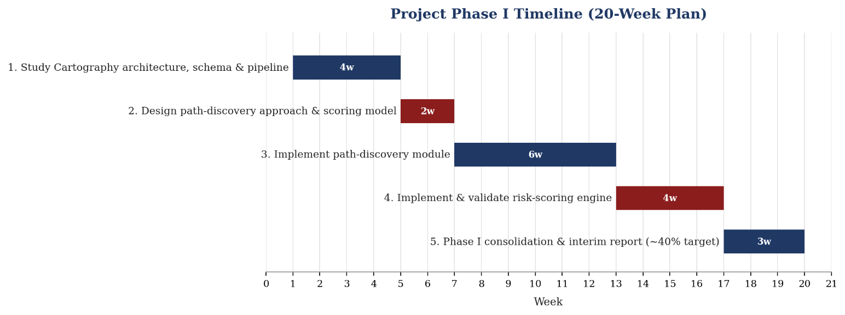

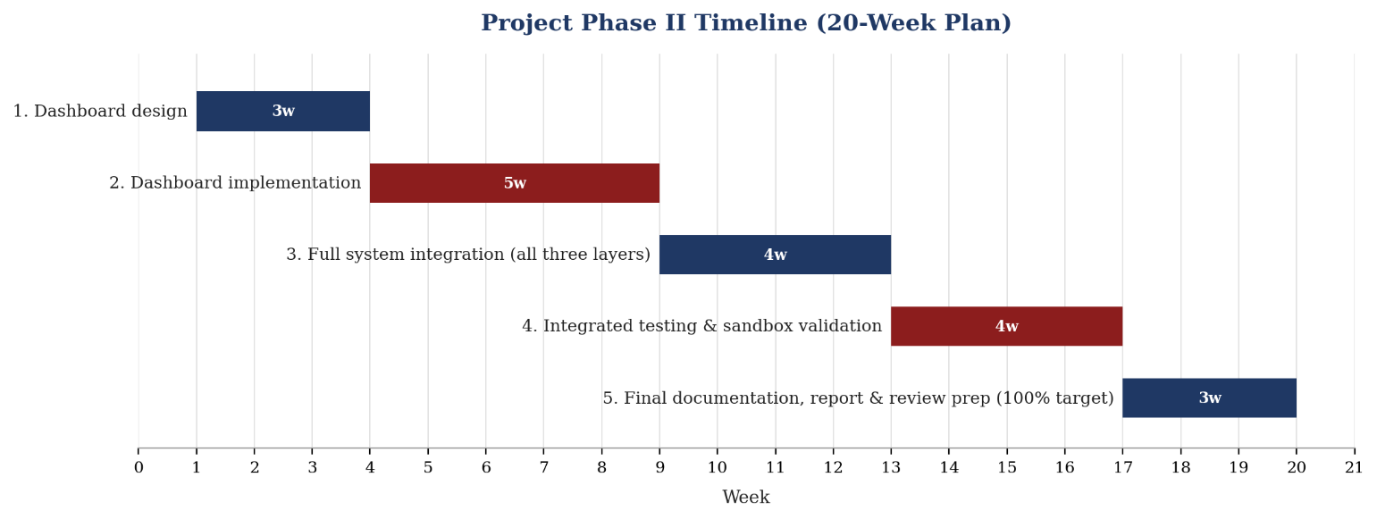
Figure 2. Full academic-year timeline — Phase I (Aug–Dec 2026) and Phase II (Jan–May 2027).

17. Work Distribution
Team Member | Primary Responsibility
Mohamed Abdul Baasid | Path discovery module; Cartography schema and intel-module study; graph query design
Rahsheetha | Risk-scoring model design, validation scenarios, and documentation of scoring justification
Kithiyon | Dashboard design and implementation; integration with backend outputs
All three members jointly study Cartography's core architecture before individual specialisation begins, and co-author the design document, so that each can independently explain the full system during evaluation.

18. References
[1] M. Lei, T. A. Madi, M. Nitschke, L. Zhao, and M. Pourzandi, "Multi-target Risk Score Aggregation for Security Evaluation of Network Environments," in Proc. 2024 IEEE Int. Conf. on Cloud Computing Technology and Science (CloudCom), 2024, pp. 71–78.
[2] Y. Hu, W. Wang, S. Khurshid, K. L. McMillan, and M. Tiwari, "Fixing Privilege Escalations in Cloud Access Control with MaxSAT and Graph Neural Networks," in Proc. 2023 38th IEEE/ACM Int. Conf. on Automated Software Engineering (ASE), 2023, doi: 10.1109/ASE56229.2023.00167.
[3] M. H. Nguyen, A. M. Ho, and B. S. To, "SkyEye: When Your Vision Reaches Beyond IAM Boundary Scope in AWS Cloud," arXiv:2507.21094, 2025.
[4] M. Kazdagli, M. Tiwari, and A. Kumar, "CloudLens: Modeling and Detecting Cloud Security Vulnerabilities," arXiv:2402.10985, 2024.
[5] P. Nandiya, A. Mohsin, A. Ibrahim, I. H. Sarker, and H. Janicke, "BRIDG-ICS: AI-Grounded Knowledge Graphs for Intelligent Threat Analytics in Industry 5.0 Cyber-Physical Systems," Cybersecurity (Springer, open access), 2026.
[6] A. Palma and S. Bonomi, "Behind the Scenes of Attack Graphs: Vulnerable Network Generator for In-Depth Experimental Evaluation of Attack Graph Scalability," Computers & Security, vol. 157, art. 104576, Oct. 2025.

